H
North Carolina Regional Transportation Planning
2014
TAC TCC HANDBOOK
User Guide for North Carolina’s Regional Transportation Planning Organizations’ Transportation Advisory Committees and Technical Coordination Committees

www.ncarpo.org

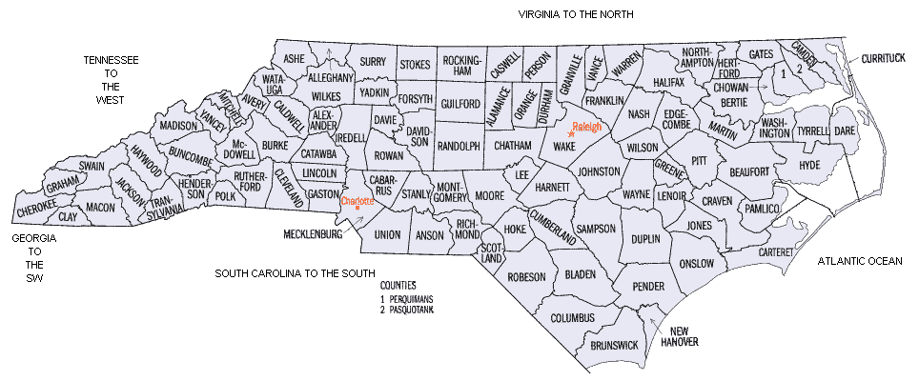
NORTH CAROLINA RPO MAP 2012

TABLE OF CONTENTS

1 / Introduction

2 / Member Roles and Responsibilities

3 / RPO Planning Processes

4 / Member Requirements

APPENDIX
Maps
RPO MOU and Bylaws
Public Involvement Plan
Prospectus
Glossary
Links (includes US Census, NADO RPO America, NCARPO, NCDOT, etc.)

1 / INTRODUCTION
Rural Planning Organizations (RPOs) were developed in response to Senate Bill 1195 which amended General Statute 136, Article 17 which directed NCDOT to develop a plan to establish RPOs. NCDOT completed its report in early 2001 and 20 RPOs were established between 2001 and 2003. As defined in 136-66.210, an RPO is “a voluntary organization of local officials formed through a Memorandum of Understanding (MOU) to work cooperatively with the Department to plan rural transportation systems and to advise the Department on rural transportation policy”.

Since 2002, the North Carolina Department of Transportation has implemented a major re-engineering of its consultation process with rural local officials. The change was mandated under a new state law passed in July 2000 that required the establishment of rural planning organizations (RPOs) to work cooperatively with the state to plan rural transportation systems and to advise the department on rural transportation policy (Senate Bill 1195, covered under Article 17 General Statue 136-210 through 213). North Carolina's RPOs are nationally recognized for their innovative and ground-breaking work.

On July 6, 2012, President Obama signed into law P.L. 112-141, the Moving Ahead for Progress in the 21st Century Act (MAP-21). Funding surface transportation programs at over $105 billion for fiscal years (FY) 2013 and 2014, MAP-21 is the first long-term highway authorization enacted since 2005. MAP-21 represents a milestone for the U.S. economy – it provides needed funds and, more importantly, it transforms the policy and programmatic framework for investments to guide the growth and development of the country’s vital transportation infrastructure.

MAP-21 creates a streamlined, performance-based, and multimodal program to address the many challenges facing the U.S. transportation system. These challenges include improving safety, maintaining infrastructure condition, reducing traffic congestion, improving efficiency of the system and freight movement, protecting the environment, and reducing delays in project delivery.

MAP-21 builds on and refines many of the highway, transit, bike, and pedestrian programs and policies established in 1991. This summary reviews the policies and programs administered by the Federal Highway Administration. The Department will continue to make progress on transportation options, which it has focused on in the past three years, working closely with stakeholders to ensure that local communities are able to build multimodal, sustainable projects ranging from passenger rail and transit to bicycle and pedestrian paths.

MAP-21 reiterates the role of earlier legislation creating North Carolina’s rural transportation planning organization by stating that States (that have not already done so) may establish and designate Regional Transportation Planning Organizations (RTPOs) and that RTPOs shall be established as a multijurisdictional organization, comprised of volunteer nonmetropolitan local officials or their designees and volunteer representatives of local transportation systems and, that he RTPOs can assist the State in addressing the needs of nonmetropolitan areas. (23 U.S.C. 135(m))

The boundaries of a RPO may coincide with, but not overlap the boundaries of a Metropolitan Planning Organization (MPO) or another RPO.

GS 136-212 identifies four primary duties for RPOs:

- Developing, in cooperation with the Department (NCDOT), long-range, local and regional multimodal transportation plans;

- Providing a forum for public participation in the transportation planning process;

- Developing and prioritizing suggestions for transportation projects the organization believes should be included in the State’s Transportation Improvement Program (STIP); and,

- Providing transportation-related information to local governments and other interested organizations and persons.

RPO Organization
According to GS 136-211 (b), an RPO must consist of at least three contiguous counties with a population of at least 50,000 people. An RPO consists of an administrative entity which provides the professional staff to the RPO, a Technical Coordinating Committee (TCC) consisting of local staff from member governments and agencies and a Transportation Advisory Committee (TAC) made up of elected and appointed officials.

Lead Planning Agency (LPA)
The LPA serves as the administrative entity for the RPO. Eligible administrative entities include a regional council of governments, regional economic development agencies, chambers of commerce and local governments. The LPA receives and expends funds on behalf of the RPO.

The LPA provides at least one (1) full time equivalent (FTE) professional staff member to carry out the duties of the RPO within the context of an adopted plan of work. The LPA is defined within the adopted Memorandum of Understanding (MOU), and may be changed based on the agreement of the RPO member governments and NCDOT. (A copy of your RPO’s MOU is included in the Appendix)

Memorandum of Understanding (MOU)
The MOU establishes the membership, bylaws and voting structure of the RPO. It also identifies the overall responsibilities of the RPO. All member counties must sign the MOU. Municipalities within the RPO may sign the MOU or adopt a resolution in support of the RPO. Any municipal resolutions must be submitted along with the MOU.

Technical Coordinating Committee (TCC)
The TCC consists of staff members from local government members, agencies and NCDOT. The TCC provides guidance and recommendations to the Transportation Advisory Committee (TAC). The TCC membership is defined within the adopted MOU.

Transportation Advisory Committee (TAC)
The TAC consists of local elected officials and a North Carolina Board of Transportation member. The TAC establishes the goals, priorities and objectives of the RPO, reviews and recommends changes to comprehensive transportation plans within its boundaries, reviews and approves an annual plan of work, and reviews and prioritizes transportation improvement projects for submission to NCDOT. The TAC membership is defined within the adopted MOU. As of 2013, TAC members are subjected to the states ethics law. Please review ethic requirements on http://www.ethicscommission.nc.gov/

Funding
The RPO program is currently funded on a reimbursement basis using Federal State Planning and Research Funds (SPR), with a 20% local match required. Allocations vary based on population and number of counties in the RPO.

Funding Agreement
Each RPO is required to adopt an agreement that establishes rules for disbursement and accounting of RPO grant funds. The Agreement for Disbursement and Accounting of Rural Transportation Planning Funds is the continuing agreement between the LPA and NCDOT. NCDOT may provide reimbursement to the designated LPA only. The LPA may enact sub- agreement(s) pertaining to the local match. A Funding Award Letter is provided to the LPA at the end of each calendar year detailing the available RPO funding for the coming fiscal year. The fiscal year runs from July 1 – June 30.

State officials worked with local officials and the existing network of regional development organizations (known locally as regional councils of government) to create 19 RPOs that serve all counties outside of the existing 19 metropolitan planning organizations (MPOs). Rural Transportation Planning Organizations shall include representatives from contiguous areas in three to fifteen counties, or a total population of the entire area represented of at least 50,000 persons according to the latest population estimate of the Office of State Budget and Management. Noncontiguous counties adjacent to the same Metropolitan Planning Organization may form a Rural Transportation Planning Organization. Areas already included in a Metropolitan Planning Organization shall not be included in the area represented by a Rural Transportation Planning Organization.
In forming the RPOs, not all of the municipalities in the region were required to join, but each county must be a member. Currently, our RPOs serve nearly 4,000,000 North Carolinians, or almost half the population of the state.

The process has provided local officials with an enhanced framework to participate in the statewide and regional planning processes. It has also provided a forum for state and local officials to discuss and address issues requiring regional solutions.
A more detailed flow chart of a typical RPO follows.

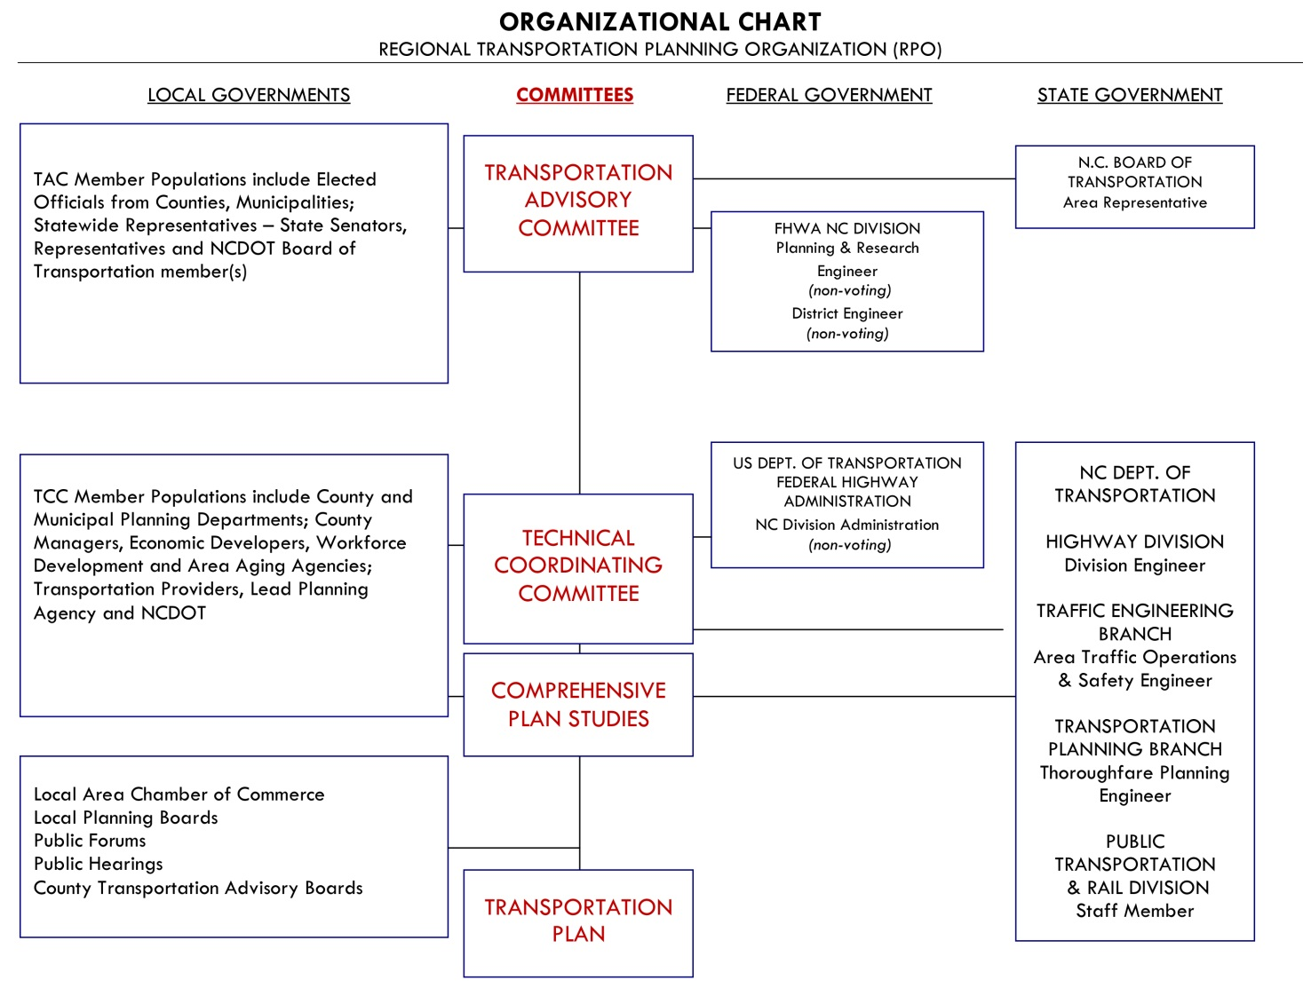

2 / MEMBER ROLES AND RESPONSIBILITIES
In all RPO’s meeting attendance is required for member organizations to remain “active”.
CHARACTERISTICS OF AN EFFECTIVE WORK TEAM
(MCGREGOR, 1960)

- The atmosphere is informal.
- Everyone participates.
- The objective of the group is well understood.
- Every idea is given a hearing.
- There is disagreement.
- There is no "tyranny of the minority".
- Sometimes there are basic disagreements which cannot be resolved (immediately).
- People are free in expressing their feelings as well as their ideas.
- When action is taken, clear assignments are made and accepted.
- The chairman of the group does not dominate it; the leadership can shift.
- The group is self-conscious about its own operations.
For TAC members, State Ethics Requirements apply. Specifically, TAC members must complete a Statement of Economic Interest (SEI) annually. For assistance with the form and the policy, please speak to your RPO Director.
For additional guidance, please refer to your RPO’s Bylaws included at the end of this Manual.
YOUR RPO’S CORE RESPONSIBILITIES TO YOUR COMMUNITY
- Developing, in cooperation with the Department (NCDOT), long-range, local and regional multimodal transportation plans;
- Providing a forum for public participation in the transportation planning process;
- Developing and prioritizing suggestions for transportation projects the organization believes should be included in the State’s Transportation Improvement Program (STIP); and,
- Providing transportation-related information to local governments and other interested organizations and persons.

EVERYONE’S ROLE IN THE RPO
UNIQUE PERSPECTIVE
You represent a unique local viewpoint from within the community; you know the area well—its people and its resources. You have a feeling for what types of policies and strategies may work and what types may not.

PLAN DEVELOPMENT
You should provide perspective and insight on information gathered as well as feedback on potential transportation improvements as they are developed. In doing so, you will play a critical part in shaping the future transportation network for decades to come. At the same time, you are not being asked to be a planner or writer; rather, you are to be a sounding board for the residents of the area.

NETWORKING
You know others in your area that have a keen interest in the way in which the area’s future transportation needs should be managed. These others may include friends, neighbors, business associates, or others vitally interested in the future of the area. By inviting these individuals to participate in the planning process, you can help make sure that all important viewpoints are embodied in the planning process. Invite your RPO Director to pertinent organizational meetings, like Chambers, Rotary or other organizations for transportation updates or formal presentations.

PUBLIC MEETINGS FACILITATION AND SUPPORT
You should feel free to engage others in the Organization and to welcome newcomers. If you attend public meetings related to planning efforts, you should reach out to and engage citizens and guests

PLAN PRESENTATION AND RECOMMENDATION
Your opinion and perspective is what makes planning processes successful. You and your RPO are the voice for transportation planning in your region.

Specific Technical Coordinating Committee / Transportation Advisory Committee Duties
TCC  TCC Member Populations include County and Municipal Planning Departments; County Managers, Economic Developers, Workforce Development and Area Aging Agencies; Transportation Providers, Lead Planning Agency and NCDOT | TAC  TAC Member Populations include Elected Officials from Counties, Municipalities; Statewide Representatives – State Senators, Representatives and NCDOT Board of Transportation member(s)
Reviews policies and procedures and recommends action to TAC | Votes on changes or adoption of policies and procedures
Reviews and recommends projects and local prioritization for statewide transportation funding. Votes to send recommendations to TAC. | Votes on regional STIP projects and prioritization process
Reviews and votes on adoption of comprehensive transportation plans (CTPs) | Votes on the adoption of CTPs
Votes to approve or disapprove administrative materials like minutes, planning work programs and public involvement plans. | Votes to approve or disapprove administrative materials like minutes, planning work programs and public involvement plans.

3 / RPO PLANNING PROCESSES
Your RPO Director will involve you in the following activities and planning processes. Your input is critical to the success of your Planning Organization. If you need clarification about any of these items, please contact your RPO Director. A complete list of project areas is included in the Appendix of the RPO Prospectus. A brief summary of these activities and processes are:

Planning Work Program (PWP)
The PWP is a standard document that consists of a funding table. The PWP is prepared on an annual basis to identify the planning priorities for the coming year and to define the planning work products and activities to be carried out by the RPO staff. Estimated expenditures for each major category of work are provided in the funding table.

Planning Work Program Amendment
Planning Work Program Amendments may be required from time to time to detail major shifts in work activities that will impact funding allocations.

Five Year Planning Calendar
The Five-Year Planning Calendar is a standard document that connects the short-term goals of the annual planning work program to the long term goals and priorities of the RPO. This should be reviewed and revised each year.

Comprehensive Transportation Planning (CTP) List of Study Needs
A Comprehensive Transportation Plan (CTP) is a collaborative effort of NCDOT planning staff, RPO staff and local jurisdiction(s). Local jurisdictions may request a CTP or an update to an existing CTP through the RPO. Each calendar year the RPO reviews and prioritizes small urban and county transportation planning study needs for their area. The CTP List of Study Needs will provide sufficient detail regarding jurisdiction, status of the local development plan, and previous transportation plans and be submitted to NCDOT annually.

Preparing a CTP Study Priority List
NCDOT will provide an updated CTP List of Study Needs Spreadsheet to your RPO Director by August 1st. Your RPO staff must review its local and regional transportation planning needs and present a prioritized CTP List of Study Needs Spreadsheet. To be eligible for inclusion on the list, each jurisdiction must have a land development plan approved within the last five (5) years or be willing to undertake a land development planning process in conjunction with the CTP.

The listing of a jurisdiction on the priority list does not guarantee that the study will be assigned or initiated and CTP studies may not be assigned in priority order because of funding, staff resources or other constraints. CTP studies may also be initiated by NCDOT in response to project delivery needs.

TIP Project Prioritization

Local Project Prioritization
Each RPO is responsible for the development of a prioritized list by mode of its region’s transportation projects (including highway, public transportation, bicycle and pedestrian, and rail projects) and the entry of those projects into the state’s prioritization process.

Preparing a TIP Priority Needs List
The State Transportation Improvement Program (STIP) is prepared by NCDOT on a biennial basis according to a schedule adopted by the Board of Transportation. The identification and prioritization of the RPO TIP project proposals should include significant input from local officials and the public.

The RPO develops a list of its region’s transportation project requests (including all modes of transportation) and enters these projects into NCDOT’s prioritization process. As part of the process, the RPO will rank or score individual projects to show their relative priority within the region.

Specific guidance related to the use of the online database for submitting transportation-related project priorities is provided by NCDOT separately. For more information regarding the process please refer to: http://www.ncdot.gov/performance/reform/.

TIP Review and Comment
After a draft STIP is released by NCDOT for public comment, the RPO reviews all information for projects within its region and makes comments as necessary regarding the accuracy of the information and any local issues or concerns. This process takes place every two years.

Merger Process
RPOs may participate in the Merger process as concurring members. Concurring members have signature authority for Merger projects in their areas and will attend Merger project meetings and adhere to the Project Team Member roles and responsibilities. Merger meetings are scheduled to discuss the progression of the project, the issues, and the steps going forward.

For more information regarding the process please refer to: http://www.ncdot.gov/doh/preconstruct/pe/MERGER01

Revising Existing Bylaws
RPOs are required to have Bylaws that define how meetings will be conducted within the RPO as well as outlining the procedure for various RPO processes. A change to the bylaws typically necessary when some aspects of the bylaws need to be clarified that was not explicitly stated in the bylaws, conflicting laws, a change in the LPA, or an MOU change. In order for the bylaws to have legal standing, the bylaws must be adopted by the TAC and should be signed by the RPO Secretary and the TAC Chairman.

Planning Work Program (PWP)
Your RPO Director must submit an adopted PWP and Five-Year Planning Calendar to NCDOT by May 31st to be eligible to receive reimbursement from NCDOT for RPO work activities in the fiscal year beginning on July 1 of the same calendar year.

PWP Timeline
November Your RPO Director will consult with NCDOT staff, RPO member governments and agencies to identify work tasks, review financial assumptions for the coming fiscal year and develop PWP, Five-Year Planning Calendar and Administrative Reporting Schedule.

January Funding Award Letter is sent to RPO detailing available funds and required local match. RPO’s prepare draft PWP for designated NCDOT staff review within 30 days of receipt of the funding letter. Release Draft PWP for public review if required by an adopted Public Involvement Plan.

February NCDOT staff comments on PWP, Five-Year Calendar, and Administrative Reporting Schedule returned to RPO within 45 days of submittal to NCDOT. RPO prepare revisions to PWP and schedule if required.

April Conduct TCC/TAC review and adoption process. Prepare revisions to PWP if required. An original signature of the TAC Chair must appear on the adopted PWP.

May Transmit one (1) digital copy of the adopted and signed PWP (PDF format), one (1) digital copy of the PWP (Excel format), and one (1) digital copy of the Administrative Reporting Schedule to designated NCDOT staff by May 31.

June PWP Approval Letter issued by NCDOT.

PWP Guidance
The Miscellaneous Expenses item is restricted to no more than 10% of the total RPO budget. The use of private consultants by an RPO is permitted for the amount of up to $5,000 with prior approval (No RFP is required),

Funds which have not been expended at the end of the fiscal year do not carry forward. If no comments are received by the dates listed above, proceed with review and adoption process according to above timeline.

Revising an Adopted PWP
Revisions to an adopted Planning Work Program are required if there is a significant change in budget, work tasks or expenditure allocation and could be processed throughout the fiscal year (as long as there will be adequate time for the public involvement and approval process through TCC, TAC and NCDOT before the end of fiscal year). All revisions to the adopted PWP must be completed by May 31st of the same fiscal year. No amendments will be processed past this date.

PWP Amendment Guidance
Review adopted PWP to determine if changes to work tasks are considered Major or Minor revisions:

Minor PWP Revisions
A variance of 100% or $2,500 (whichever is less) for a category is considered a minor revision and is allowed without amendment if approved in advance by the TPB RPO Coordinator. RPO Director will prepare revised funding table noting adopted and revised funding amounts.

Major PWP Revisions
A variance of more than 100% or $2,500 (whichever is lower) for a category is considered a major revision and requires amendment and must be reviewed and approved by both the TCC and TAC.

4 / APPENDIX

